Experiment 13
You are tasked with developing an Online Learning Platform. The
platform should include the following functionalities:
1. Course Enrollment and Registration
2. Video Lecture Streaming
3. Interactive Quizzes and Assignments
4. Progress Tracking Dashboard
5. Peer-to-Peer Discussion Forums
6. Certificate Generation
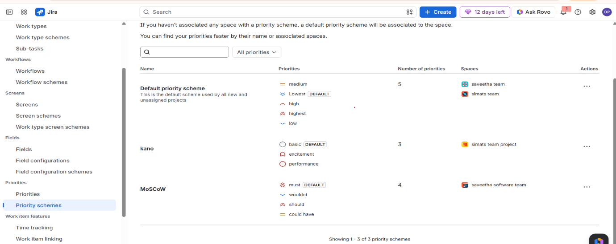
Use Jira to categorize and prioritize these requirements using

